2.Number Speaks Included in Homepage   
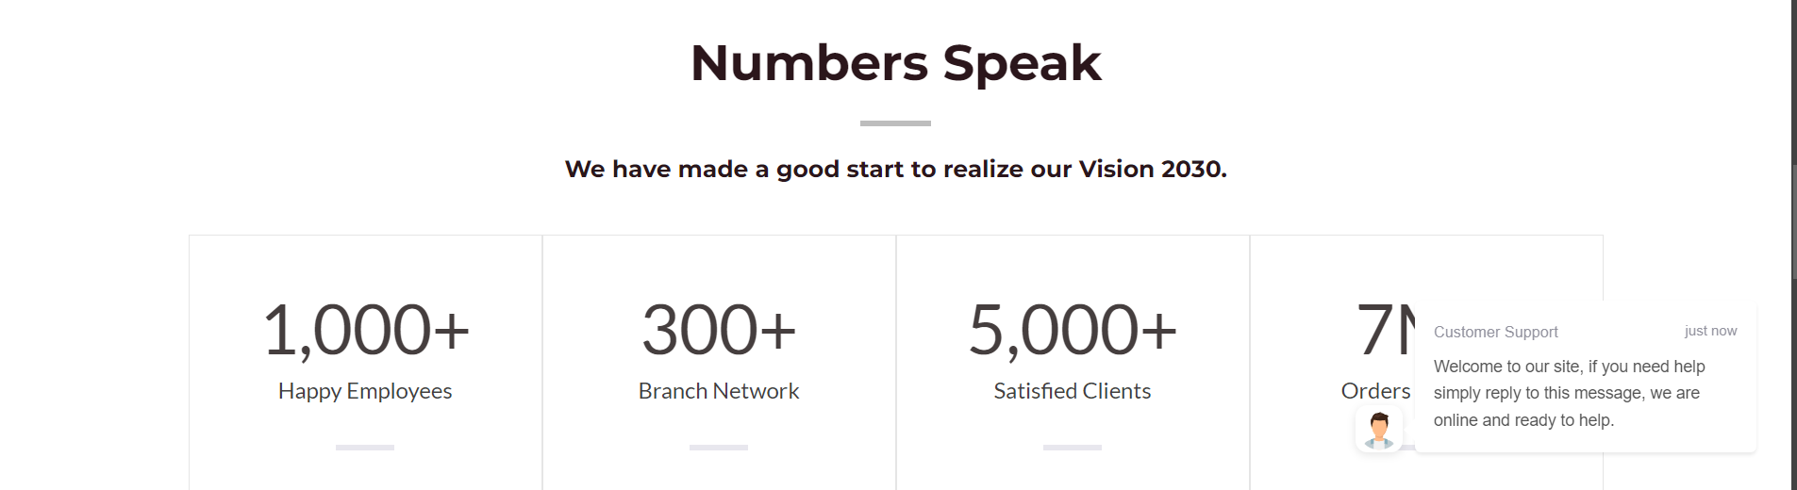

1. Hero Section down to the Navbar  
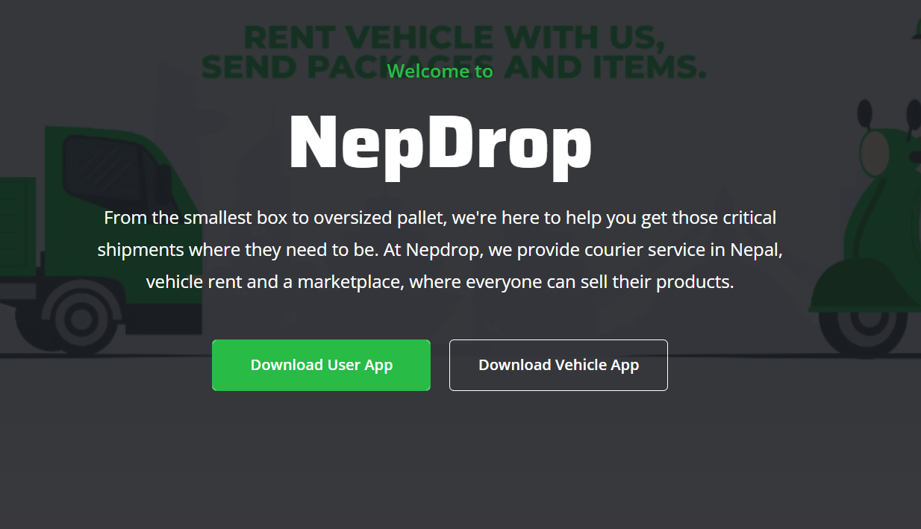

3. Our Services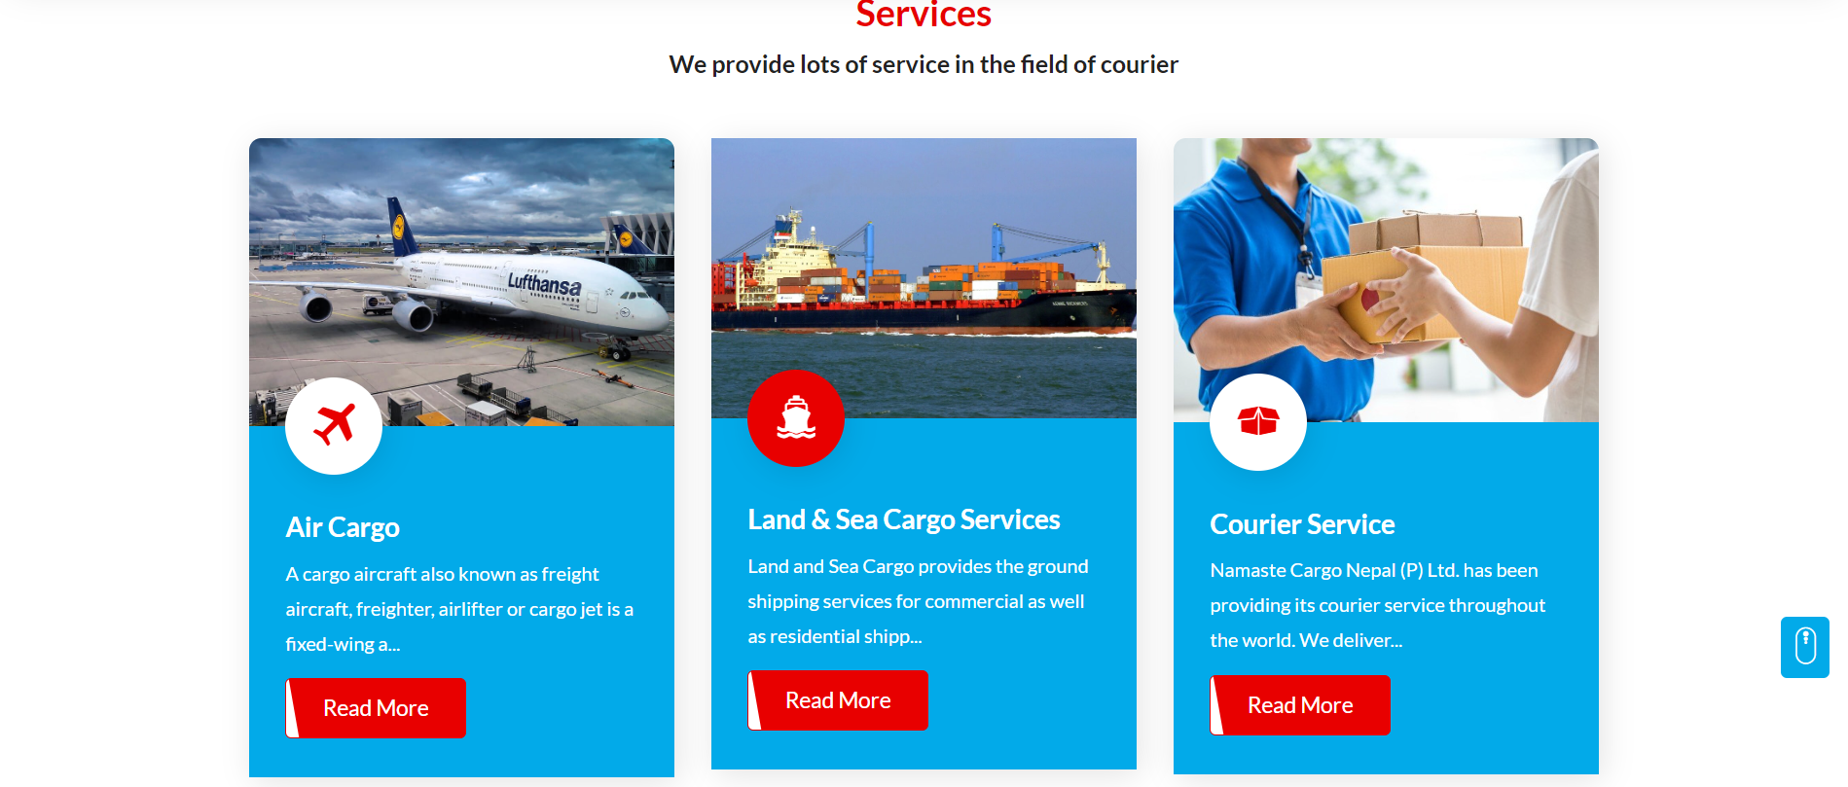

4. Customer Ratings

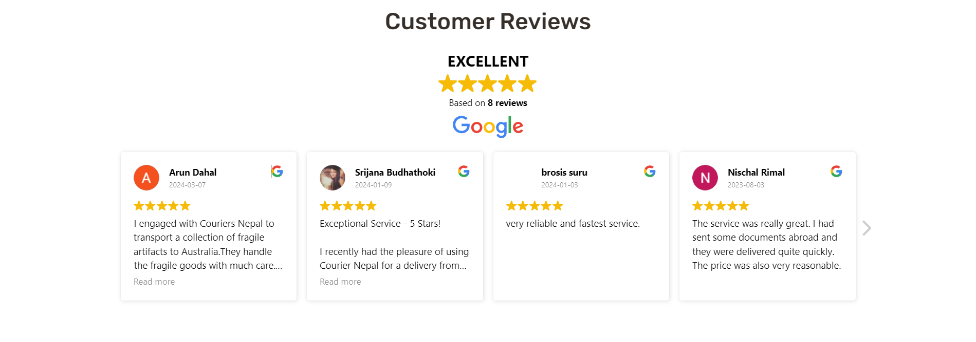

5. top navbar



6. Track Package



7. Minimilstic Navbar

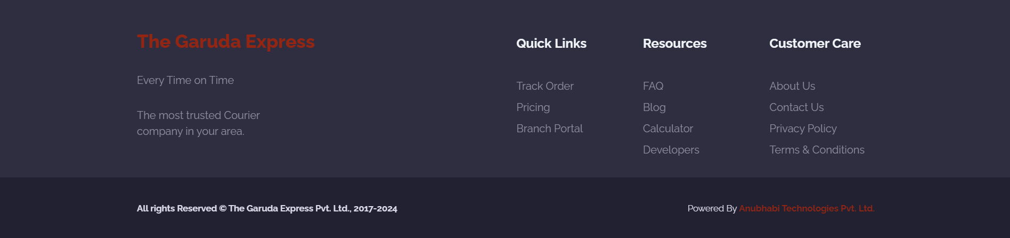

7. Navbar

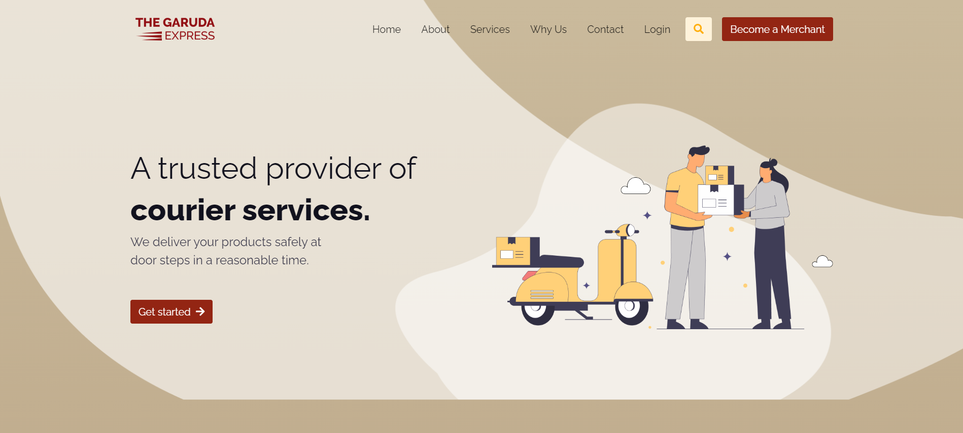

8. Testimonials

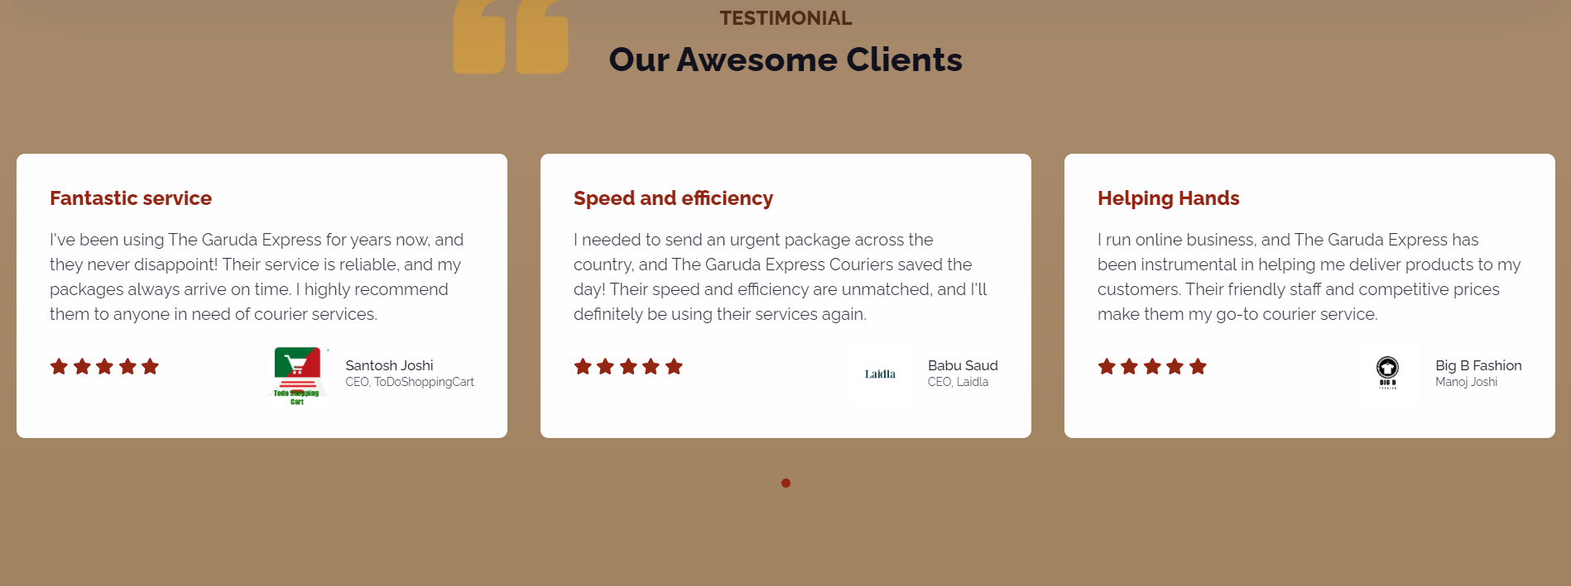

9. Navbar Idea



10. Testimonials and navbar

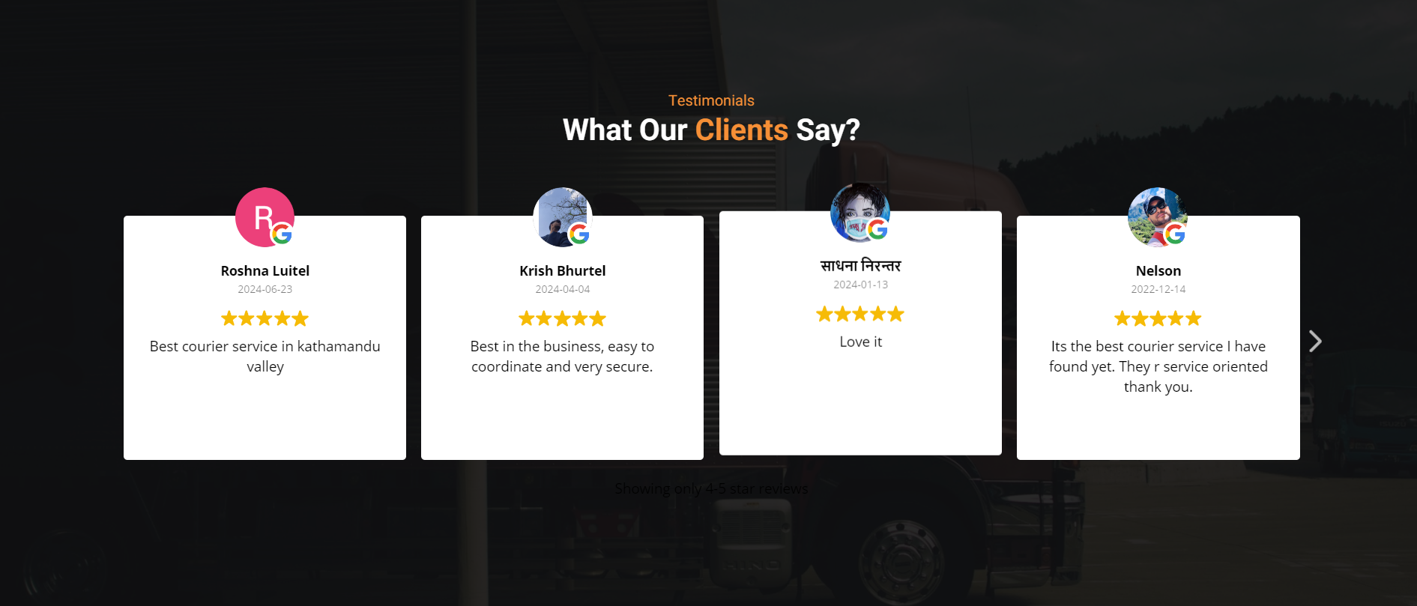

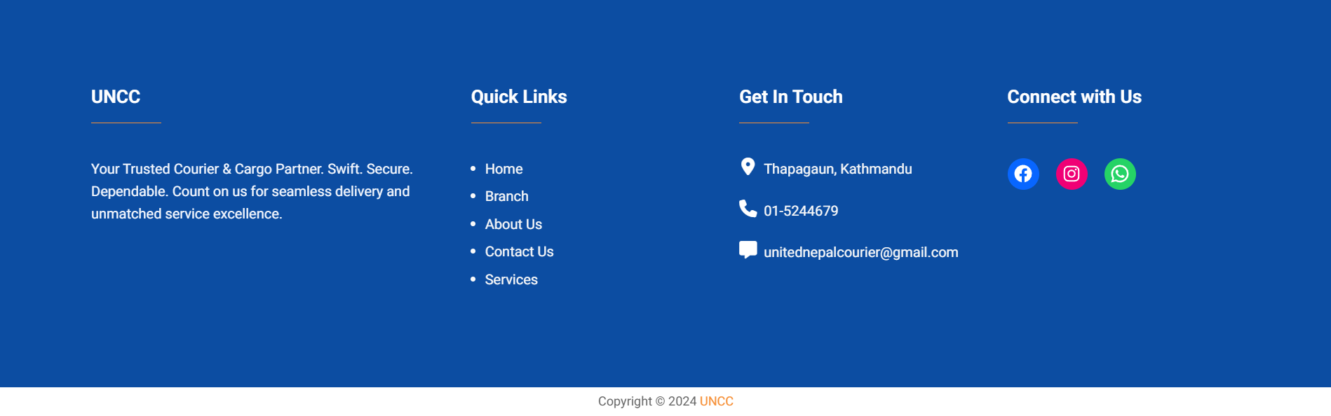

10. Hero Section

